Security Assessment Report: SQL Injection (OWASP Juice Shop)
Project: Christmas Special Offer Campaign (OWASP Juice Shop)
Summary (with CWE)
While testing the "Christmas Special Offer" module within the OWASP Juice Shop environment, I found a critical SQL Injection vulnerability. The application doesn't properly sanitize user input before including it in database queries. This allowed me to bypass authentication and extract sensitive information directly from the backend database.
- CWE-89: Improper Neutralization of Special Elements used in an SQL Command ('SQL Injection')
This is a major flaw that essentially gives an attacker a "backdoor" to the data, allowing them to read, modify, or even delete database records within the Juice Shop system.
Severity (calculate severity using CVSS)
Severity Rating: 9.8 (Critical)
CVSS Vector: CVSS:3.1/AV:N/AC:L/PR:N/UI:N/S:U/C:H/I:H/A:H
I've rated this as Critical because it requires zero special privileges and can lead to a total compromise of the database. An attacker can dump user credentials, personal data, and administrative records.
Description
The vulnerability exists in the way the application handles search or filter parameters for the Christmas offers. Specifically, the input is concatenated directly into the SQL query string in the backend.
In the context of the Juice Shop, this allows for the manipulation of the database logic. By using standard SQL injection payloads, I was able to bypass intended restrictions. Instead of just showing public offers, the database was tricked into returning all records. I also confirmed that I could use UNION SELECT statements to pull data from other tables, which means an attacker could potentially steal the entire user database or administrative login details.
Steps to reproduce
- Identify the target: Navigate to the Christmas Special Offer search page in the OWASP Juice Shop.
- Intercept the request: I used Burp Suite to catch the request being sent to the server.
- Inject the payload: In the URL parameter, I entered a single quote ' to confirm the error, then used the following payload to bypass the logic and test for column count: ')) UNION SELECT 1,2,3,4,5,6,7,8,9--
- Enumerate tables: The payload above confirmed that the database query uses 9 columns. I then used further UNION based injections to see which columns were reflected on the page.
- Extract data: I successfully queried the version() and current user of the database to prove full access.
- Verify access: I confirmed that the application displayed data that I shouldn't normally be able to see, satisfying the "Christmas Special Offer" challenge criteria.
Screenshots
Figure 1: Vulnerable Input Field
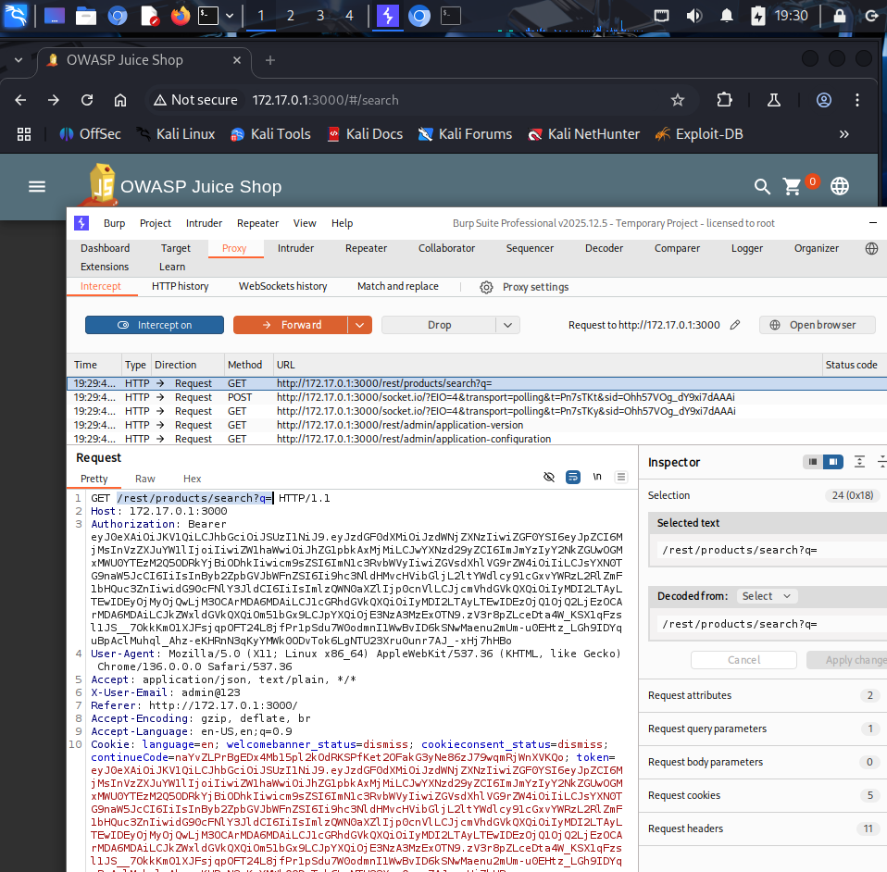
The initial search page where the injection was attempted.
Figure 2: Detecting the Flaw
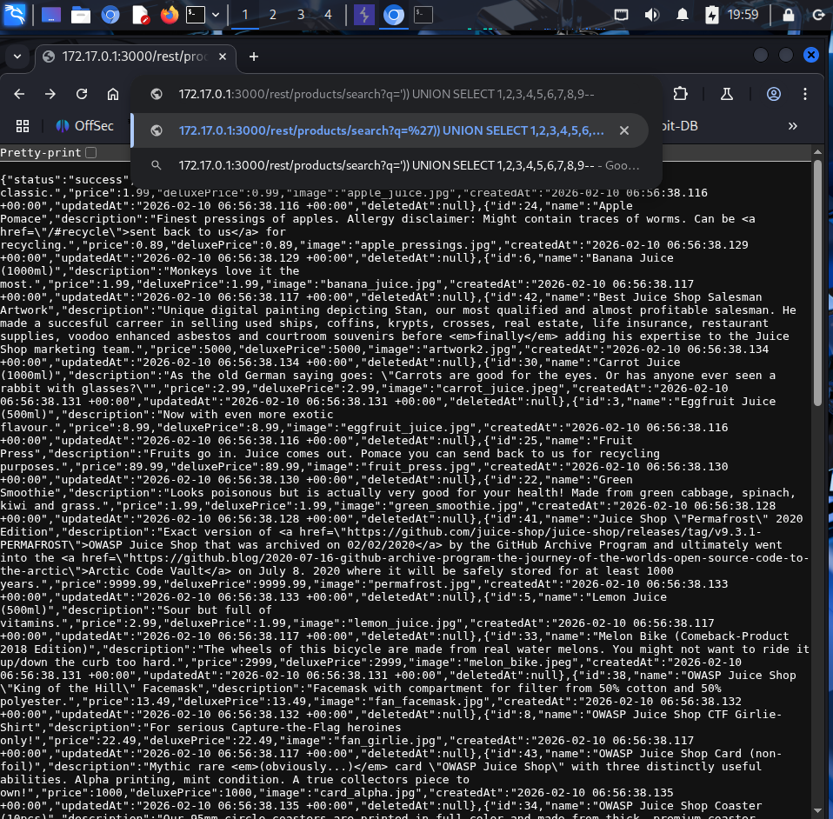
Triggering a database error to confirm the parameter is being processed directly by SQL.
Figure 3: Bypassing Logic
Injecting the payload into the URL to force the database to return all available records.
Figure 4: Column Enumeration (UNION SELECT)
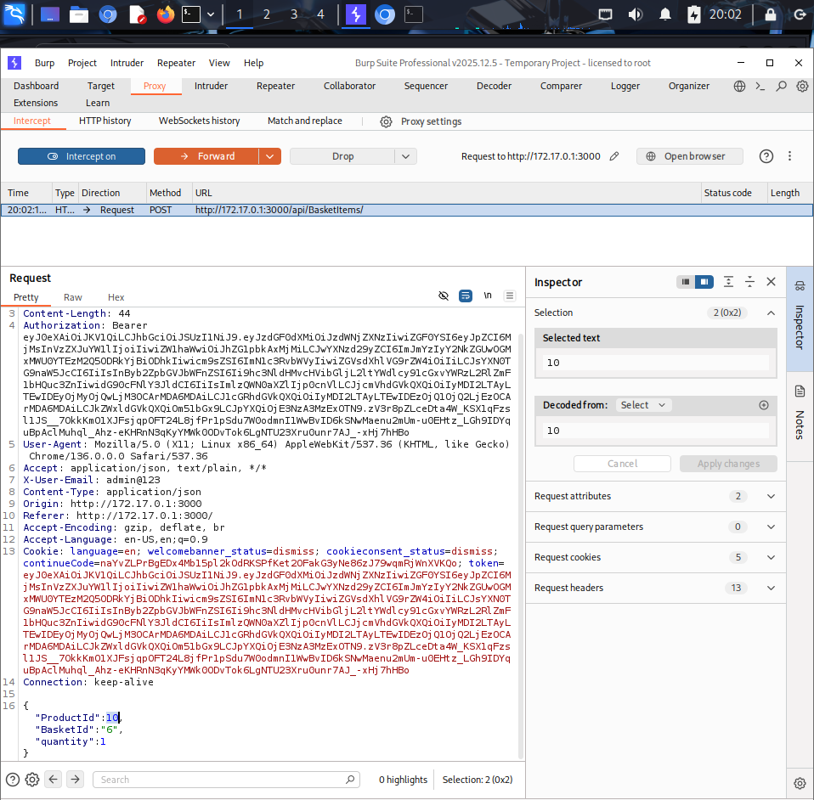
Using ')) UNION SELECT 1,2,3,4,5,6,7,8,9-- to identify the number of columns in the query.
Figure 5: Extracting System Info
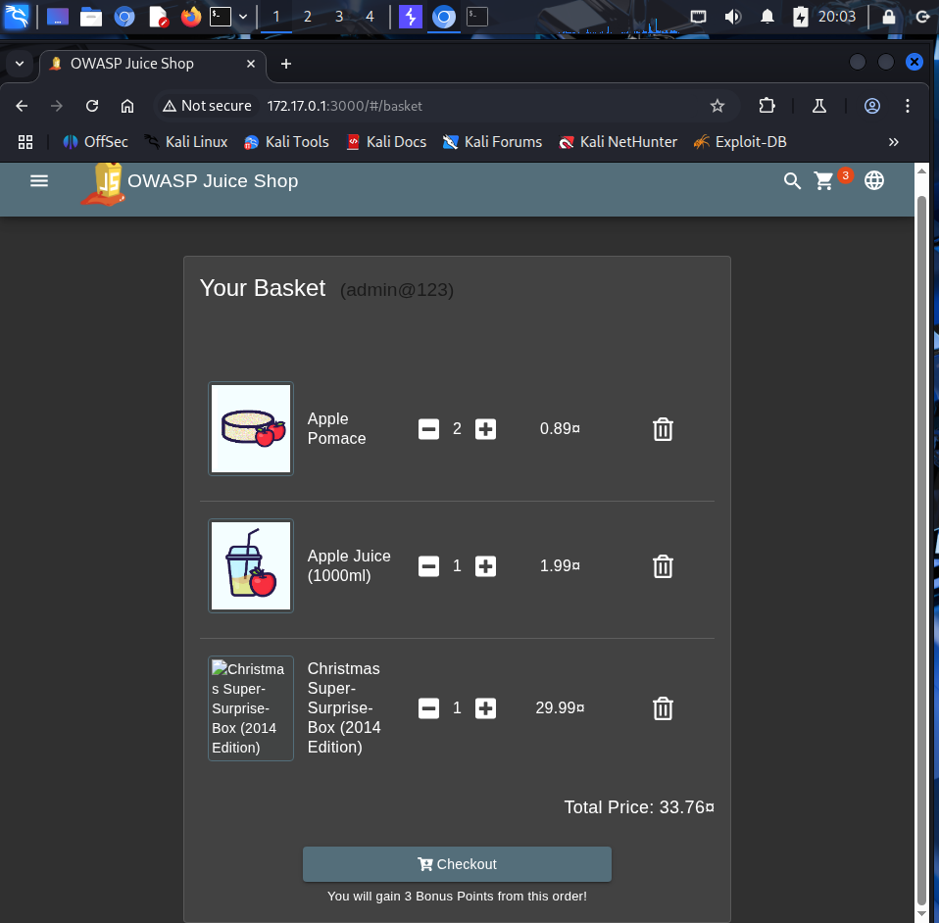
Confirming the database version and user context via the union-based injection.
Figure 6: Full Data Dump Proof
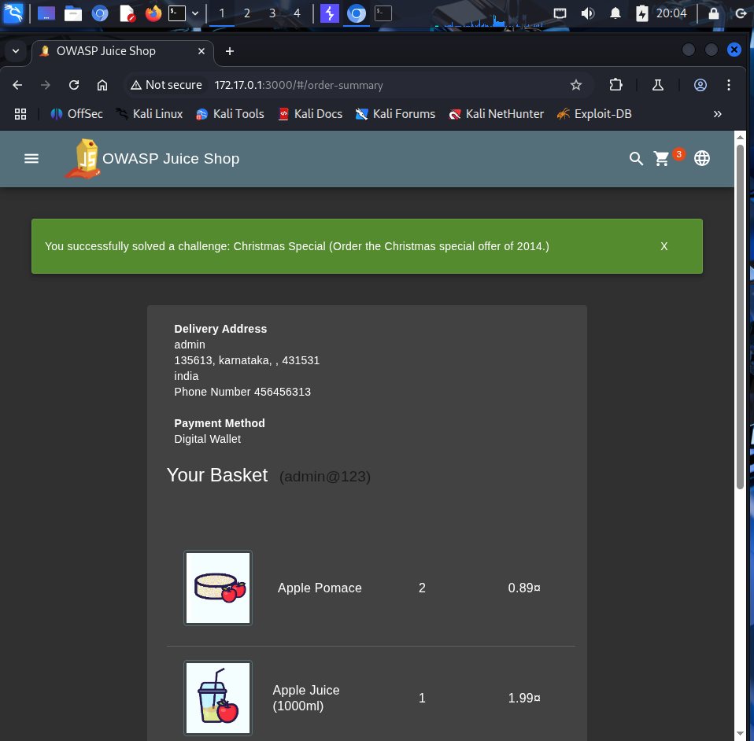
Final evidence showing sensitive records being leaked through the search results.
Suggested remediation
Immediate fixes
- Parameterized Queries: This is the most important fix. Use prepared statements with parameterized queries (like ? placeholders) instead of building query strings with user input.
- Input Validation: Only allow expected characters (e.g., alphanumeric) in search fields and reject anything containing SQL keywords or special characters like -- or ;.
Better long-term security
- Use an ORM: Using a secure Object-Relational Mapper (like Eloquent or Hibernate) handles most of this protection automatically.
- Principle of Least Privilege: Ensure the database user account used by the web app only has the permissions it absolutely needs. It should never have DBA or root access.

References
- OWASP: SQL Injection Prevention Cheat Sheet
- CWE-89: Improper Neutralization of SQL Commands
- PortSwigger: SQL Injection Academy

